**Calculating Area and Volumes of Shapes with GUI**

**Dalton Coughlin**

How to use application:

1. Open program with java main.java in the command line
2. Select a shape selection
3. Once selection is chosen a separate window will open with that specified shape
4. Enter the needed fields to calculate volume or area of respective shape
5. Hit submit to calculate area or volume
6. Calculations will take place and it will be shown as along side a picture of the shape
7. One can keep opening new windows if they have the old one open of new shapes

Note: Below is GUI of Application

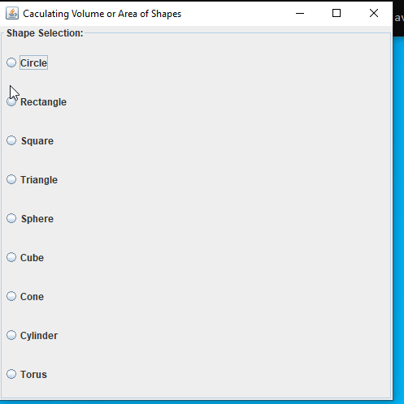

Developer Reflection:

This isn’t my first GUI that I have built in java so the GUI building process went smoothly. The challenge for me how I wanted to switch between fields for entering information for the shapes. I thought about generating a panel and destroying it every time a radio button was chosen, but in the end, I decided building a new JFrame per selection was ideal. It added a cool functionally with being able to keep old shape calculations up while working on new ones. One feature I didn’t add but should of was wiping the old JPanel when working with a certain shape. It will allow one to do multiples, but it has a FlowLayout so the layout will start to become overcrowded.

I was able to refactor almost all my code from my last project besides adding some getters to my old classes which didn’t take very long. Using previous code that I wrote is something I always try to do to save time whether at work, school, or personal use. My favorite part of the project was finding a way out to build new JFrames inside another JFrame. I knew it was something that could be done but haven’t done it in Java before. Funny enough I had to do the exact same thing with Tkinter with a Python application I am working on at work today as well. The one thing I could have worked on better was the design of the project with lining up results and text fields equal to every Jframe, it’s always been my sour point in application development and web development. I’m on more of the side of functionality and back-end development.

Test Case Circle:

Expected:

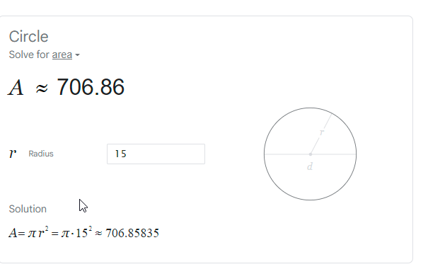

Results:

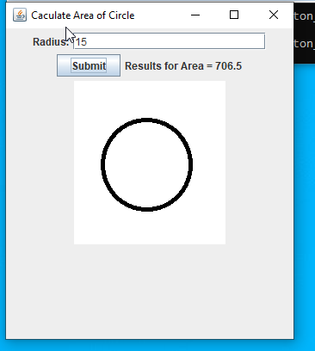

Test Case Rectangle:

Expected:

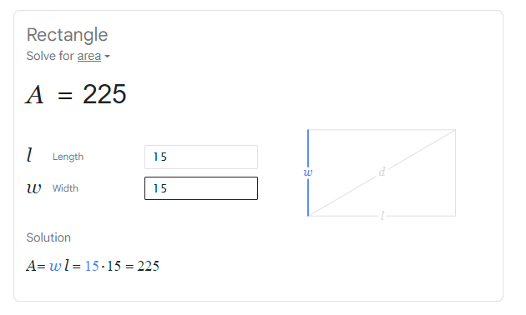

Results:

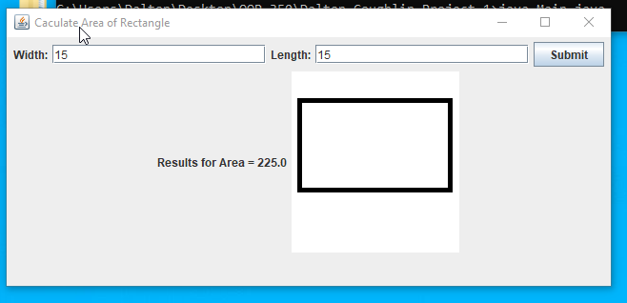

Test Case Square:

Expected:

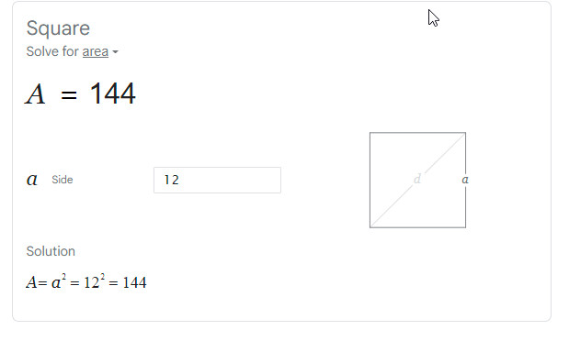

Results:

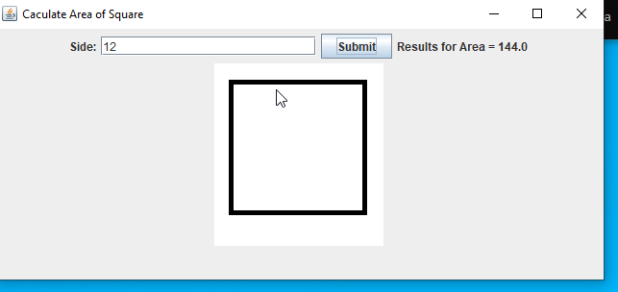

Test Case Triangle:

Expected:

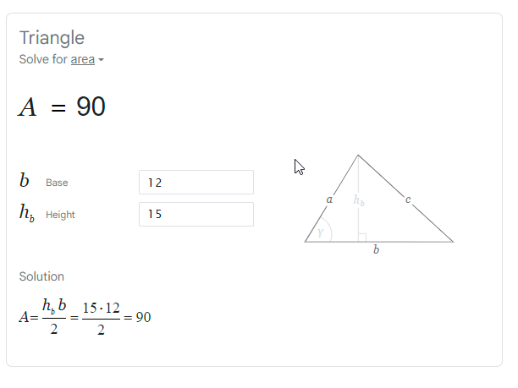

Results:

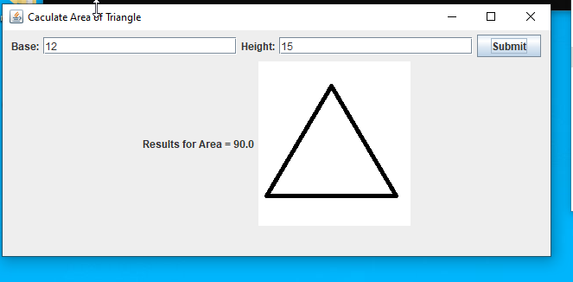

Test Case Sphere:

Expected:

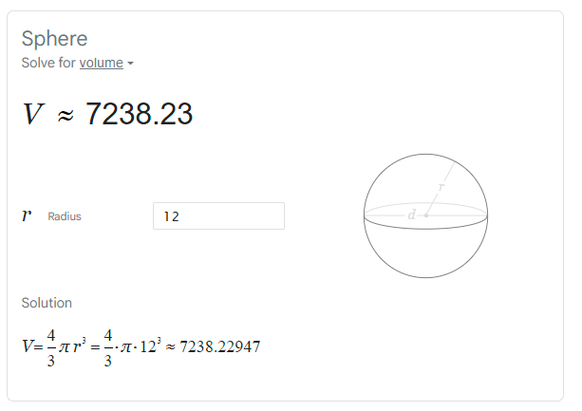

Results:

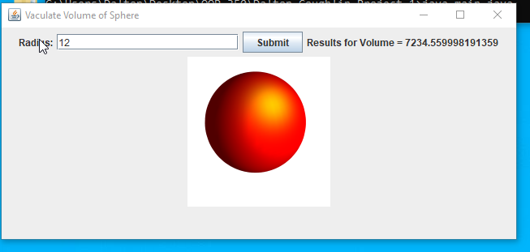

Cube:

Expected:

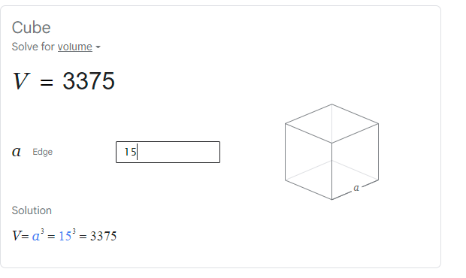

Results:

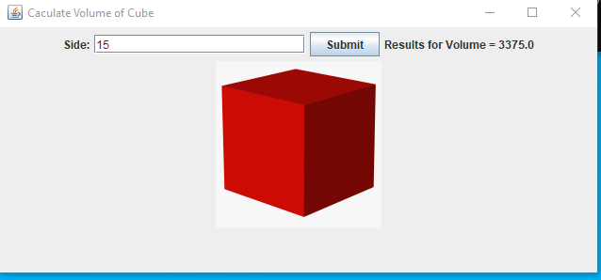

Cone:

Expected:  
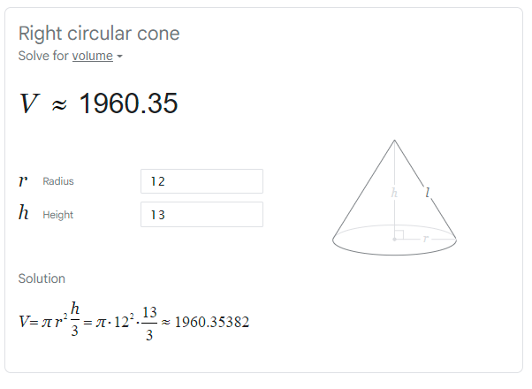

Results:

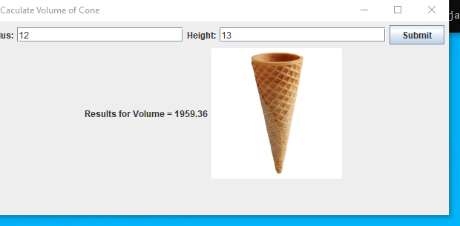

Cylinder:

Expected:

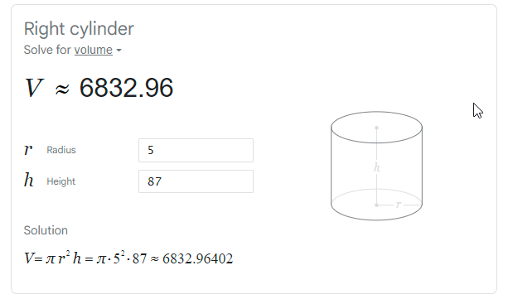

Results:

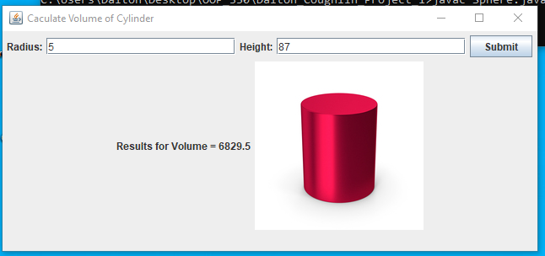

Torus:

Expected:

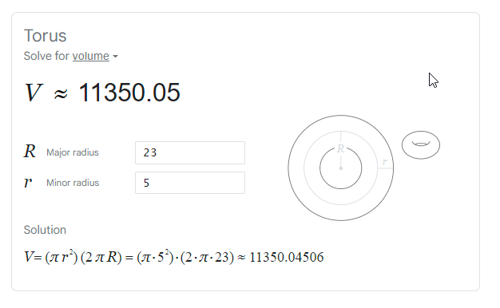

Results:

